VIKAS BHARATI PUBLIC SCHOOL
SAMPLE PAPER (SESSION 2024-25)
CLASS: XI
SUBJECT: SOCIOLOGY (039)
Time : 3 Hrs M.M : 80
________________________________________________________________________________________
Note: This question paper contains 4 printed pages.

General Instructions

1. The question paper is divided into four sections.
2. There are 35 questions in all. All questions are compulsory.
3. Section A includes question No. 1-16. These are MCQ type questions. As per the question, there can be one answer.
4. Section B includes question No.17-25. These are very short answer type questions carrying 2 marks each. Answer to each question should not exceed 30 words.
5. Section C includes question No. 26-32. They are short answer type questions carrying 4 marks each. Answer to each question should not exceed 80 words.
6. Section D includes question No. 33-35. They are long answer type questions carrying 6 marks each. Answer to each question should not exceed 200 words each.
7. Question no. 35 is to be answered with the help of the given passage.

 | SECTION A
1. | Which one among the subsequent is so important for the society that its violation imply severe punishment?  - Customs b) Ideologies c) Mores d) Folkways | 1
2. | A system of economic enterprise supported the economic exchange is thought as  - Capitalism b) Industrialization c) Modernization d) Westrnization | 1
3. | A peer group is a kind of__________ group.  - Primary b) Secondary c) Association d) None of these | 1
4. | The behaviours, obligatons and privileges attached to social status is known as  - Status set b) Role set c) Social role d) Status symbol | 1
5. | The ______, sometimes called the ‘outcastes’ are inferior to all other castes.  Brahmins b) Panchamas c) Kshatriyas d) Shudras | 1
6. | Assertion (A): In a traditional caste system social hierarchy is fixed, rigid and transmitted across generations.  Reason (R): Due to lack of advancement, rural society practice traditional caste system.  a. Both A and R are true and R is the correct explanation of A.  - Both A and R are true and R is not the correct explanation of A.  - A is true but R is false.  - A is false but R is true. | 1
7. | _______________ can be defined as a set of symbols and beliefs providing the sense of being part of a single political community.  - Nationalism b) Secularism c) Communalism d) Socialism | 1
8. | Which of the following statement is/are true about Culture.  - A way of thinking, feeling, believing  - The total way of life of a people  - An abstraction from behaviour  - Learned behaviour  OPTIONS: a) i only b) i and iii only c) ii only d) All of these | 1
9. | The word ‘peer’ means  - Equal b) Friend c) Student d) None of these | 1
10. | Assertion (A): The Calvinists believed that the world was created for the glory of God.  Reason (R):. Any work in this world had to be done for God glory, making even mundane works acts of worship.  a. Both A and R are true and R is the correct explanation of A.  - Both A and R are true and R is not the correct explanation of A.  - A is true but R is false.  - A is false but R is true. | 1
11. | Arrange the following in chronological order:  - The French Revolution  - The Russian Revolution  - The tsunami hit Indonesia, Sri Lanka, the Andaman Islands and parts of Tamil Nadu  - Introduction of Railway in India  ORDER: a) i, iii, iv and ii b) i, iv, ii and iii c) iv, iii, i and ii d) iii, iv, i and ii | 1
12. | ___________ proposed theory of the survival of the fittest.  - Charles Darwin b) Max Webber c) Karl Marx d) Durkheim | 1
13. | Who wrote book ‘Division of Labour in society’?  - Durkheim b) Webber c) Karl Marx d) None of these | 1
14. | Who argued that human society had progressed through different stages. These were: primitive communism, slavery, feudalism and capitalism.  - Karl Marx b) Durkheim c) Webber d) Gidden | 1
15. | Which were three principles of change recongnised in Indian traditions by D.P. Mukherji?  - Shruti, Smriti and Anubhava c) Shruti, Smriti and Simran  - Smriti, Anubhava and Pryatan d) Anubhava, Shruti and Sparsh | 1
16. | Which is/are the features of a welfare state?  - A welfare state is a positive state c) The welfare state is a democratic state  - A welfare state involves a mixed economy d) All of these | 1
 | SECTION B
17. | State any four features of sociology. | 2
18. | In what ways did the Industrial Revolution lead to the birth of sociology in Europe? | 2
19. | Differentiate between state society and stateless society. | 2
20. | Define microsociology and macrosociology. | 2
21. | Study the picture given bellow and answer the following question.  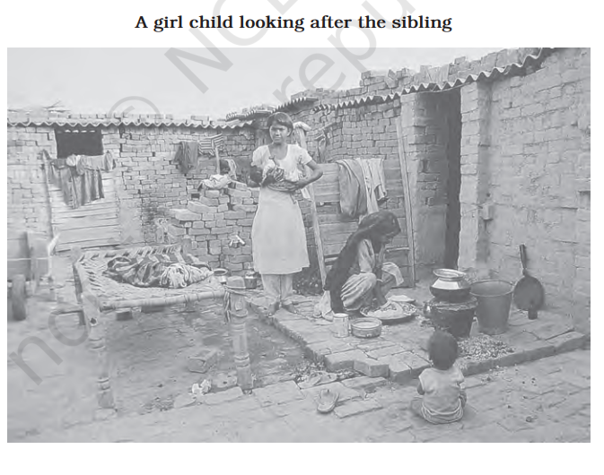  What are the potential negative impacts on a girl child when she is expected to take on the responsibility of looking after her siblings at a young age? | 2
22. | Explain the Functionalist perspective of social control. | 2
23. | Define the term Gentrification. | 2
24. | Explain the importance of the comparative study method.  OR  Give the characteristics of religion. | 2
25. | Discuss two different approaches to studying cultural change. | 2
 | SECTION C
26. | What is society? Describe the main characteristics of society. | 4
27. | How ‘Ascribed Status’ is different from ‘Achieved Status’?  OR  Explain the concept of social stratification. | 4
28. | Write an essay on ‘work’. Focus on both the range of occupations, which exist and how they change. | 4
29. | Explain various agencies of socialization.  OR  Explain material aspects of culture. | 4
30. | What are some features of social order in rural areas? | 4
31. | Why do classes come into conflict, according to Karl Marx? | 4
32. | Discuss G.S. Ghurye’s contribution in Sociology. | 4
 | SECTION D
33. | What are the basic features of bureaucracy?  OR  How was the Industrial Revolution responsible for giving rise to sociology? | 6
34. | What are some of the challenges to social order in urban areas?  OR  What is meant by social order and how is it maintained? | 6
35. | Read the following paragraph and answer the questions:  Nature, ecology and the physical environment have always had a significant influence on the structure and shape of society. This was particularly true in the past when human beings were unable to control or overcome the effects of nature. For example, people living in a desert environment were unable to practise settled agriculture of the sort that was possible in the plains, near rivers and so on. So the kind of food they ate or the clothes they wore, the way they earned their livelihood, and their patterns of social interaction were all determined to a large extent by the physical and climatic conditions oftheir environment. The same was true for people living in very cold climates, or in port towns, along major trade routes or mountain passes, or in fertile river valleys. But the extent to which the environment influences society has been decreasing over time with the increase in technological resources.  - How did nature and the physical environment influence society in the past?  - Why were people in desert environments unable to practice settled agriculture?  - What has reduced the influence of the environment on society over time? | 6

