# VIKAS BHARATI PUBLIC SCHOOL

**SAMPLE PAPER (SESSION 2024-25)**

**CLASS: IX**

# SUBJECT: SOCIAL SCIENCE (087)

## Time: 3 Hours M.M 80

***Note: 1. This question paper contains 7 printed pages.***

## 2. IMPORTANT INSTRUCTIONS:

1. The question paper comprises six sections – A, B, C, D, E and F. There are 37 questions in the paper. All questions are compulsory.
2. Section A – From questions 1 to 20 are MCQs of 1 mark each.
3. Section B – Questions no. 21 to 24 are Very Short Answer Type Questions, carrying 2 marks each. The answer to each question should not exceed 40 words.
4. Section C contains Q. 25 to Q.29 are Short Answer Type Questions, carrying 3 marks each. Answer to each question should not exceed 60 words.
5. Section D – Questions no. 30 to 33 are long answer type questions, carrying 5 marks each. Answer to each question should not exceed 120 words.
6. Section-E - Questions no. 34 to 36 are case-based questions with three sub-questions and are of 4 marks each.
7. Section F – Question no. 37 is map-based, carrying 5 marks with two parts, 37a from History (2 marks) and 37b from Geography (3 marks). Attach the map with the answer sheet.
8. There is no overall choice in the question paper. However, an internal choice has been provided in a few questions. Only one of the choices in such questions must be attempted.
9. In addition to this, separate instructions are given with each section and question, wherever necessary.

|  |  |  |
| --- | --- | --- |
|  | **SECTION A MCQ’s (1X20=20)** |  |
| **1.** | **What is the Old Regime?**  a) The society and institutions of France before 1789 .  b) The period when the storming of the Bastille occurred.  c) The society and institutions of France after 1789.  d) The period when the French society divided into a different sections. | 1 |
| **2.** | **Look at the picture given below. Identify the name of the leader from the following options:**  April 2022 – carlitoboricua  a) Stalin b) Tsar Nicholas I  c) Rasputin d) Lenin | 1 |
| **3.** | **Which physical feature of India is known for its youthful topography with high peaks, deep valleys and fast flowing rivers?**    a) Northern Plains b) Himalayas c) Plateaus d) Coastal Plains | 1 |
| **4.** | **The systematic, organized punishment of those belonging to a group or religion is referred to ________________.**   1. Persecution b) Genocide c) Pauperized d) Propaganda | 1 |
| **5.** | **Arrange the following in chronological order.**   1. Bloody Sunday incident. 2. October Revolution 3. Abdication of Tsar Nicholas II 4. Provisional Government came into power   **Options:**   1. i, ii, iii, iv b) ii, iii, iv, i   c) i, iii, iv , ii d) iii, iv, i, ii | 1 |
| **6.** | **India has had strong geographical and historical links with her neighbouring countries. Identify the country that does not share the land border with India.**  a) Nepal b) Maldives c) Myanmar d) Afghanistan | 1 |
| **7.** | **The states that lie along the eastern coast of India from north to south are :**     1. West Bengal, Odisha, Andhra Pradesh and Tamil Nadu 2. Punjab, Haryana, Uttar Pradesh, Bihar 3. Maharashtra, Goa, Karnataka, Kerala 4. Rajasthan, Punjab, Maharashtra, Kerala | 1 |
| **8.** | **Read the following annual report provided by UGC and identify the year that had maximum enrolment of students in universities.**    a) 1950-51 b) 1989-99 c) 2014-15 d)2016-17 | 1 |
| **9.** | **The current anti-poverty strategy of the government is based on which two planks?**     1. Promotion of economic growth. 2. Targeted anti-poverty programme. 3. Unequal distribution of land and other resources.   a) (i) and (ii) b) (ii) and (iii)  c) (i) and (iii) d) None of these | 1 |
| **10.** | **Japan did not have natural resources yet it has emerged as a developed country because:**     * 1. They have invested in human resource, especially in the field of education and health.   2. People’s efficiency and technology have made the country rich and developed.   3. Other resources such as land and capital have not been effectively utilized.  1. Statement (i) is correct c) Statement (ii) is correct   b) Statement(ii) and (iii) are correct d) Statement (i) and (ii) are correct | 1 |
| **11.** | **Which among the following pair is incorrectly matched?**   |  |  | | --- | --- | | **Column 1** | **Column 2** | | a. Proof of Identity | Ration Card | | b. EC | Election Code | | c. Incumbent | Current Holder of a Political Office | | d. Electronic Voting Machine | EVM | | 1 |
| **12.** | **Which of the following yojna has been launched to bring the assisted poor families above the poverty line by organizing them into self-help groups through a mix of bank credit and government subsidy?**   1. Mahatma Gandhi National Rural Employment Guarantee Act ( MNREGA) 2. Antyodaya Anna Yojana ( AAY) 3. Pradhan Mantri Gramodaya Yojana ( PMGY) 4. Swarnjayanti Gram Swarozgar Yojana (SGSY) | 1 |
| **13.** | |  |  |  | | --- | --- | --- | | **Under unemployment, people are not in jobs during some months of the year.** | | | |  |  | | a) Disguised b)Seasonal | c) Educated d) Urbane | | 1 |
| **14.** | **An activity performed for profit or for service can be termed as:**  a)Formal Activity b) Market Activity c) Non Market Activity d) Professional Activity | 1 |
| **15.** | **Which type of hunger is a consequence of diets persistently inadequate in terms of quantity and quality?**   1. Fast kept due to spiritual reasons c) Chronic Hunger 2. Seasonal Hunger d) None of these | 1 |
| **16.** | **An assembly of people’s representatives with the power to enact laws for a country is called ________________.**  a) Executive b) Judiciary c) Legislature d) Media | 1 |
| **17.** | **Name the country in which General Pervez Musharraf overthrew a democratically elected government and declared himself the Chief Executive of this country.**   1. Pakistan b) Mexico c) Zimbabwe d) Saudi Arabia | 1 |
| **18.** | **Who had played a key role in the making of the constitution but had a different understanding of how inequalities could be removed.**  a) Dr. B.R.Ambedkar c) Dr. Rajendra Prasad  b) Jawaharlal Nehru d) Somnath Lahiri | 1 |
| **19.** | **Mr. Saxena's application was rejected as the post was reserved for SC candidates but he belonged to General Category. Which of the following is true with reference to this.**  A. His fundamental right. i.e., Right to Equality is violated.  B. Government has the right to reserve some posts for SC and ST candidates.   1. Both A and B are true c) A is true but B is false 2. Both A and B are false d) A is false but B is true | 1 |
| **20.** | **In the question given below, there are two statements marked as Assertion (A) and Reason (R). Read the statements and choose the correct options.**  **Assertion (A):** The Lok Sabha exercises more powers in money matters.  **Reason(R):** The Rajya Sabha is the permanent house.     1. A is wrong but R is correct. 2. Both A and R are true, but R is not the correct explanation of A. 3. A is correct but R is wrong. 4. Both A and R are true, and R is the correct explanation of A. | 1 |
|  | **SECTION B**  **VERY SHORT ANSWER(2x4=8)** |  |
| **21.** | Write a short note on Liberals. | 2 |
| **22.** | Name the outermost range of the Himalayas. Mention any one feature of this range.  **OR**  Differentiate between Climate and Weather. | 2 |
| **23.** | Explain the meaning of Socialist and Secular with reference to the Preamble of the Indian Constitution. | 2 |
| **24.** | “The MSP is declared by the government every year before the sowing season to provide incentives to farmers for raising production of the crops”. Elaborate. | 2 |
|  | **SECTION C**  **SHORT ANSWER(3x5=15)** |  |
| **25.** | Write differences between Active and Passive Citizens.  **OR**  Explain Lenin’s ‘April Theses’. | 3 |
| **26.** | Discuss the major components of population growth in India. | 3 |
| **27.** | Who appoints Election Commissioner of India? Mention his/her two powers. | 3 |
| **28.** | Explain the three dimensions of food security. | 3 |
| **29.** | ‘Investment in education is important for the growth of people.’ Discuss any three steps that have been taken by the government to improve education system in India. | 3 |
|  | **SECTION D**  **LONG ANSWER(5x4=20)** |  |
| **30.** | Describe the legacy of the French Revolution for the peoples of the world during the nineteenth and twentieth centuries.  **OR**  Explain what role women had in Nazi Germany. | 5 |
| **31.** | Give an account of weather conditions and characteristics of cold weather season.  **OR**  Why monsoon is considered a unifying bond in India? | 5 |
| **32.** | Enumerate the five merits of democracy.  **OR**  Elaborate the challenges to free and fair elections in India. | 5 |
| **33.** | Explain the major causes of poverty in India.  **OR**  Write a note on the role of cooperatives in providing food and related items in India. | 5 |
|  | **SECTION E**  **CASE BASED ANSWER(4x3=12)** |  |
| **34.** | **Read the following extract and answer the questions asked.**  The period of the early Planned Economy was linked to the disasters of the collectivisation of agriculture. By 1927- 1928, the towns in Soviet Russia were facing an acute problem of grain supplies. The government fixed prices at which grain must be sold, but the peasants refused to sell their grain to government buyers at these prices.  Stalin, who headed the party after the death of Lenin, introduced firm emergency measures. He believed that rich peasants and traders in the countryside were holding stocks in the hope of higher prices. Speculation had to be stopped and supplies confiscated.  In 1928, Party members toured the grain-producing areas, supervising enforced grain collections, and raiding ‘kulaks’ – the name for well to-do peasants. As shortages continued, the decision was taken to collectivise farms. It was argued that grain shortages were partly due to the small size of holdings. After 1917, land had been given over to peasants. These small-sized peasant farms could not be modernised. To develop modern farms, and run them along industrial lines with machinery, it was necessary to ‘eliminate kulaks’, take away land from peasants, and establish state-controlled large farms.   * 1. Who headed the party after the death of Lenin?   2. State any one impact of Stalin’s collectivisation programme.   3. Why was it necessary to establish state-controlled large farms? | 1+1+2=4 |
| **35.** | **Read the following extract and answer the questions asked.**  The drainage systems of India are mainly controlled by the broad relief features of the subcontinent. Accordingly, the Indian rivers are divided into two major groups :-   * The Himalayan Rivers * The Peninsular Rivers.   Apart from originating from the two major physiographic regions of India, the Himalayan and the Peninsular rivers are different from each other in many ways. Most of the Himalayan rivers are perennial. These rivers receive water from rain as well as from melted snow from the lofty mountains. The two major Himalayan rivers, the Indus and the Brahmaputra originate from the north of the mountain ranges. The Himalayan rivers have long courses from their source to the sea.  A large number of the Peninsular rivers are seasonal, as their flow is dependent on rainfall. During the dry season, even the large rivers have reduced flow of water in their channels. The Peninsular rivers have shorter and shallower courses as compared to their Himalayan counterparts. However, some of them originate in the central highlands and flow towards the west. Most of the rivers of peninsular India originate in the Western Ghats and flow towards the Bay of Bengal.   * 1. Where do the Himalayan Rivers receive water from?   2. Name the largest Peninsular river of India.   3. Mention any two characteristic features of the Peninsular Rivers. | 1+1+2=4 |
| **36.** | **Read the following extract and answer the questions asked.**  The drafting of the document called the constitution was done by an assembly of elected representatives is called the Constituent Assembly. The manner in which the Constituent Assembly worked gives sanctity to the Constitution. The Constituent Assembly worked in a systematic, open and consensual manner. First some basic principles were decided and agreed upon. Then a Drafting Committee chaired by Dr. B.R. Ambedkar prepared a draft constitution for discussion. Several rounds of thorough discussion took place on the Draft Constitution, clause by clause. More than two thousand amendments were considered. The members deliberated for 114 days spread over three years. Every document presented and every word spoken in the Constituent Assembly has been recorded and preserved. These are called ‘Constituent Assembly Debates’. When printed, these debates are 12 bulky volumes! These debates provide the rationale behind every provision of the Constitution. These are used to interpret the meaning of the Constitution.   * 1. Define the term Constituent Assembly.   2. Who was the chairman of the drafting committee?   3. Mention the important characteristics of the Constituent Assembly Debates. | 1+1+2=4 |
|  | **SECTION F**  **MAP SKILL BASED QUESTION (2+3=5)** |  |
| **37** | **37a) Two places A and B have been marked on the given outline map of the World, identify them and write their correct names on the lines drawn near them.**   1. Country which fought in the first world war as Allied power. 2. Country which fought in the first world war as Central power. | 2 |
|  | **37b) On the outline map of India locate and label any three of the following:**   1. Gujarat 2. Sambhar Lake 3. The State having highest density of population 4. Mountain Peak- Kanchan Junga | 3 |

**NAME ____________________________ CLASS & SECTION ____________ ROLL No. _________**

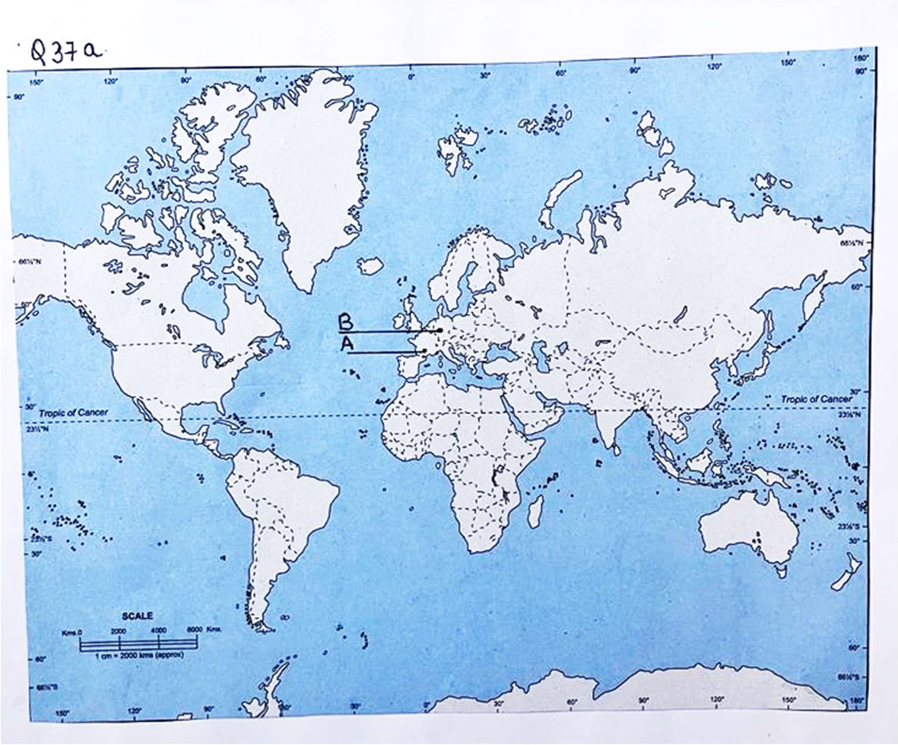

**37b)**

